Group: 5
Team Members:
- Timothy Do,
- Chris Kelamyan
Date: 04/07/2026
Assignment: Requirements Engineering #3

Data Requirements
AccountiBuzz is built around six core data entities that support its accountability workflow:
- User: Stores account and profile information for each individual, including display name,
email, and timezone.
- Group: Defines the structure and rules of each challenge created by administrators,
including the challenge title, description, daily deadline, and mode (competitive or
collaborative).
- GroupMember: Connects users to groups and tracks each member's role (member, co-admin, or
admin) and participation status.
- Submission: Records daily proof uploads from users, including the media file URL, type
(photo or video), submission timestamp, and review status.
- Streak: Maintains each user's consistency within a group by tracking consecutive
participation days, grace day usage, and streak freeze status.
- Notification: Logs reminders and feedback sent to users, including the notification type
and delivery intensity preference.

Entity Relational Diagram - ERD
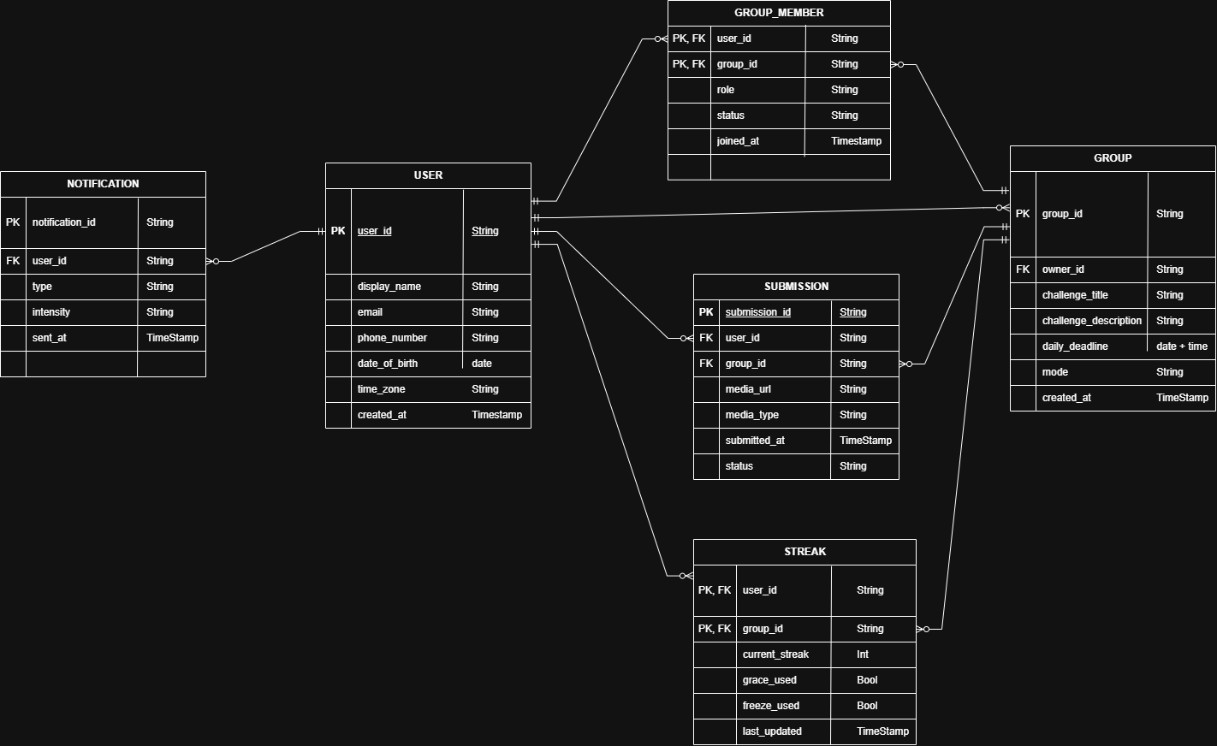

Data Dictionary
USER
Field | Type | Required | Description | Constraints
user_id | string | Yes | Unique identifier for a user | Auto-generated by Firebase Auth; must be unique; cannot be null
display_name | String | Yes | Name visible to group members | Max 50 characters; cannot be null
email | String | Yes | User's email address used for login | Must be unique; valid email format; cannot be null
phone_number | String | No | User's phone number | Optional; E.164 format (e.g. +1234567890)
date_of_birth | Date | No | User's date of birth | Optional; used for account recovery; must be a valid past date
time_zone | String | Yes | User's timezone for accurate deadline calculations | Must be a valid IANA timezone (e.g. "America/Los_Angeles"); auto-detected on registration
created_at | Timestamp | Yes | Date and time the account was created | Auto-set on registration; cannot be modified

GROUP
Field | Type | Required | Description | Constraints
group_id | string | Yes | Unique identifier for a group | Auto-generated; must be unique; cannot be null
owner_id | String | Yes | user_id of the group creator and admin | FK references USER.user_id; cannot be null
challenge_title | String | Yes | Name of the daily challenge | Max 100 characters; cannot be null
challenge_description | String | Yes | Details and rules of the challenge | Max 500 characters; cannot be null
daily_deadline | Timestamp | Yes | Time by which members must submit proof each day | Defaults to 23:59 local time; set by admin
mode | String | Yes | Group display mode | Must be "competitive" or "collaborative"; cannot be null
created_at | Timestamp | Yes | Date and time the group was created | Auto-set on creation; cannot be modified

GROUP_MEMBER
Field | Type | Required | Description | Constraints
user_id | string | Yes | ID of the member | PK, FK references USER.user_id; cannot be null
group_id | String | Yes | ID of the group | PK, FK references GROUP.group_id; cannot be null
role | String | Yes | Member's role within the group | Must be "member", "co_admin", or "admin"; cannot be null
status | String | Yes | Member's current participation status | Must be "active" or "paused"; defaults to "active"
joined_at | Timestamp | Yes | Date and time the member joined the group | Auto-set on joining; cannot be modified

STREAK
Field | Type | Required | Description | Constraints
user_id | string | Yes | ID of the member | PK, FK references USER.user_id; cannot be null
group_id | String | Yes | ID of the group | PK, FK references GROUP.group_id; cannot be null
current_streak | Integer | Yes | Number of consecutive days the member has completed the challenge | Cannot be negative; defaults to 0
grace_used | Boolean | Yes | Whether the member has used their weekly grace day | Resets every week; defaults to false
freeze_used | Boolean | Yes | Whether the member has used their streak freeze this 30-day cycle | Resets every 30 days; defaults to false
last_updated | Timestamp | Yes | When the streak was last recalculated | Auto-updated after each submission review

SUBMISSION
Field | Type | Required | Description | Constraints
submission_id | string | Yes | Unique identifier for a submission | Auto-generated; must be unique; cannot be null
user_id | String | Yes | ID of the member who submitted | FK references USER.user_id; cannot be null
group_id | String | Yes | ID of the group the submission belongs to | FK references GROUP.group_id; cannot be null
media_url | String | Yes | Firebase Storage URL pointing to the proof file | Must be a valid URL; cannot be null
media_type | String | Yes | Type of proof submitted | Must be "photo" or "video"; cannot be null
submitted_at | Timestamp | Yes | Timestamp when submission was initiated (not upload completion) | Auto-set at initiation; cannot be modified
status | String | Yes | Current review status of the submission | Must be "pending", "approved", "rejected", or "flagged"; defaults to "pending"

NOTIFICATION
Field | Type | Required | Description | Constraints
notification_id | string | Yes | Unique identifier for a notification | Auto-generated; must be unique; cannot be null
user_id | String | Yes | ID of the user receiving the notification | FK references USER.user_id; cannot be null
type | String | Yes | Category of the notification | Must be "submission_reminder", "review_result", or "admin_reminder"
intensity | String | Yes | Notification delivery intensity preference | Must be "gentle" or "firm"; set by user in settings
sent_at | Timestamp | Yes | Date and time the notification was sent | Auto-set when notification is dispatched

CRUD Matrix:
Create, Read, Update, Delete
CRUD Matrix
Feature | USER | GROUP | GROUP_MEMBER | SUBMISSION | STREAK | NOTIFICATION
Register | C
Login | R
Create Group | R | C | C
Join Group | R | R | C
Submit Proof | R | R | R | C |  | C
Review Submission | R | R | R | U | U | C
View Leaderboard | R | R | R |  | R
Send Reminder | R | R |  |  |  | C
Pause Streak |  |  | U
Use Free Pass |  |  |  |  | U

Reporting / Dashboard Views
1. Leaderboard (Competitive Mode)
- Who sees it: All members in Competitive mode
- Shows ranked list by streak count, updates in real-time
- Data from: STREAK, GROUP_MEMBER, USER

2. Completion Board (Collaborative Mode)
- Who sees it: All members in Collaborative mode
- Shows who submitted today vs who hasn't, no ranking
- Data from: SUBMISSION, GROUP_MEMBER, USER

3. Submission Review Queue
- Who sees it: Admins only
- Shows pending submissions with Approve / Request Resubmission / Flag actions
- Data from: SUBMISSION, USER, GROUP_MEMBER

4. My Streak Dashboard
- Who sees it: Individual member
- Shows streak count, grace day status, free pass status, pause toggle
- Data from: STREAK, SUBMISSION

5. Group Activity Feed
- Who sees it: All members
- Shows today's submissions chronologically + milestone broadcasts
- Data from: SUBMISSION, STREAK, USER, GROUP_MEMBER

Non-Functional Requirements
External Requirements
ID | Category | Description
NFR-EXT-001 | Performance | Screens shall load within 2 seconds under normal network conditions
NFR-EXT-002 | Performance | Proof uploads shall begin processing within 3 seconds of submission initiation
NFR-EXT-003 | Reliability | The app shall display a user-friendly error message on any network or server failure. There should be no raw error codes shown to users
NFR-EXT-004 | Reliability | Submissions shall queue offline and auto-retry on reconnection without user action
NFR-EXT-005 | Usability | The app shall support both light mode and dark mode
NFR-EXT-006 | Usability | A first-time user shall be able to register, join a group, and submit proof within 5 minutes
NFR-EXT-007 | Usability | All push notifications shall deep-link directly to the relevant screen when tapped
NFR-EXT-008 | Availability | The app shall be available on Android via Expo for v1; iOS support deferred

Internal Requirements
ID | Category | Description
NFR-INT-001 | Security | User passwords shall be managed exclusively by Firebase Auth. No plaintext passwords stored
NFR-INT-002 | Security | Firebase Firestore security rules shall ensure users can only read/write data they are authorized to access
NFR-INT-003 | Security | Media proof files in Firebase Storage shall only be accessible to members of the relevant group
NFR-INT-004 | Scalability | The Firebase architecture shall support adding new group members and submissions without schema changes
NFR-INT-005 | Maintainability | Code shall follow the naming conventions defined in CONVENTIONS.md
NFR-INT-006 | Maintainability | Each screen and component shall have a single clearly defined responsibility
NFR-INT-007 | Compatibility | The app shall support Android using a shared Expo codebase; iOS deferred to v2

Prototype
Here’s a short demo video for our prototype.

Accountibuzz_demo.mp4

